

eMDR Submission

Work Instruction

Purpose

The purpose of this work instruction is to assist individuals with the preparation and submission of an incident report to the FDA utilizing FDA’s eSubmitter software.

Scope

This work instruction applies to the creation of eMDRs utilizing FDA’s eSubmitter software and the submission of eMDRs utilizing FDA’s ESG Gateway portal.

This work instruction applies to subcontractors/consultants performing eMDR submission on behalf of SILQ.

Documents

Reference Documents

QM.SLQ022 Medical Device Reporting

Appendices / Associated Forms / Templates

FM1-QM.SLQ021 Product Complaint File Form

Definitions

Abbreviations / Acronyms

eMDR: Electronic Medical Device Report

ESG: Electronic Submissions Gateway

General Definitions

Electronic Submissions Gateway: FDA’s internet portal for accepting electronic regulatory submissions (e.g., eMDRs).

FileHold: Software based document management system used to electronically store controlled documents.

Responsibilities

It is the responsibility of QA/RA to comply with the requirements of this procedure.

QA/RA management is responsible for ensuring compliance with this document by SILQ personnel and sub-contractors/consultants.

Regulatory Affairs is responsible for preparation and submission of electronic MDRs to FDA.

Procedure: Steps to Create an eMDR using FDA’s eSubmitter program

Click on the coffee cup icon to launch the FDA’s eSubmitter program, which is the FDA software that allows you to create an electronic MDR report (MedWatch 3500A form). It is advisable to have all the required information (device information, narrative description, coding, etc.) ready before you create the report.



Click “Create New Submission”. 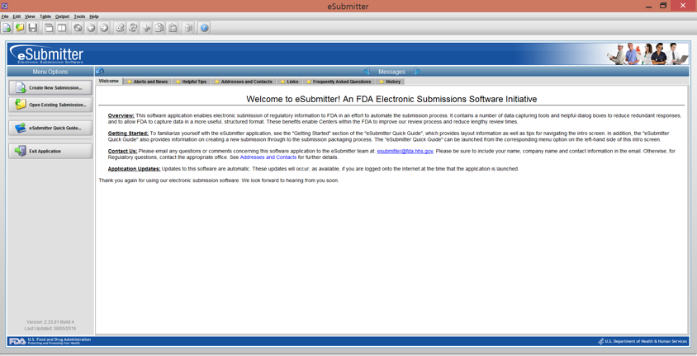

Select “CDRH: Medwatch Form 3500A” from the list and then click the “Next” button.

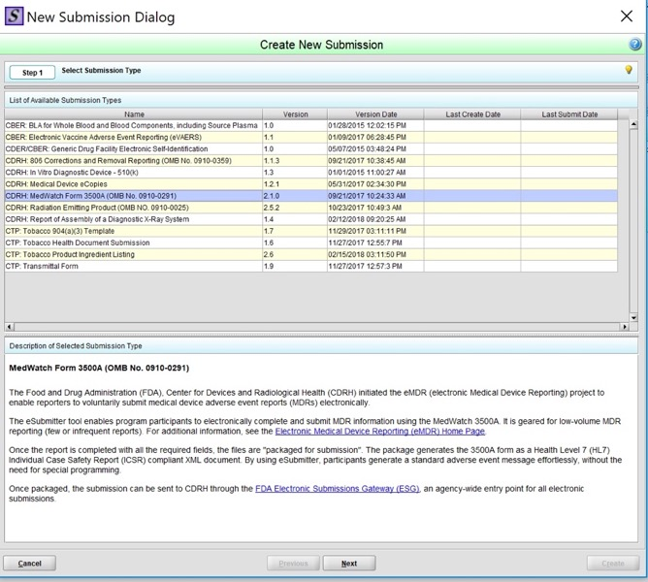

Enter a unique, Descriptive Name and a File Name for the .xml eMDR file and then click the “Create” button.

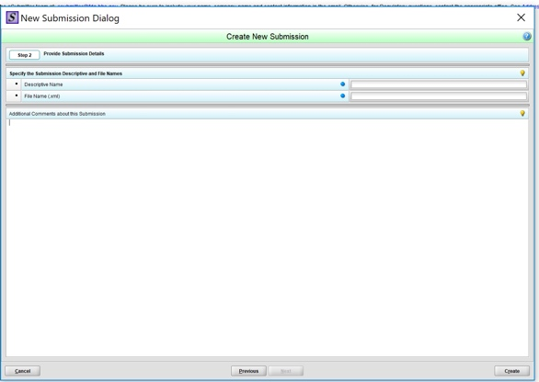

Once you click the “Create” button, you will be directed to the screen shown below and you can begin entering the required fields of the 3500A MedWatch Form.

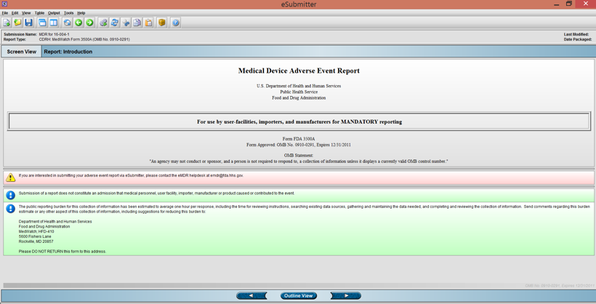

Refer to the FDA website for the “Instructions for Completing Form 3500A” (web link below) which provides detailed instructions on how to complete the form.

Instructions for Completing FDA Form 3500A:

https://www.fda.gov/Safety/MedWatch/HowToReport/DownloadForms/ucm149236.htm

Refer to the FDA website for assistance with adverse event codes.

Enter the appropriate codes for Patient, Device, Method, Results, and Conclusions. Additional codes can be entered in section H10.

MDR Adverse Event Codes

https://www.fda.gov/medicaldevices/deviceregulationandguidance/postmarketrequirements/reportingadverseevents/mdradverseeventcodes/default.htm

Coding Resources

https://www.fda.gov/MedicalDevices/DeviceRegulationandGuidance/PostmarketRequirements/ReportingAdverseEvents/MDRAdverseEventCodes/ucm584205.htm

How to Code:

https://www.fda.gov/MedicalDevices/DeviceRegulationandGuidance/PostmarketRequirements/ReportingAdverseEvents/MDRAdverseEventCodes/ucm584204.htm

For detailed instructions on how to navigate the eSubmitter software, launch eSubmitter and access the User Manual, Quick Guide, and the FAQs from the Home screen (aka the Welcome screen) and under Help in the menu bar at any time. (note that these instructions are for the use of eSubmitter software and are not specific to eMDRs).

eSubmitter Tutorial Videos

https://www.fda.gov/forindustry/fdaesubmitter/ucm193862.htm

In order to navigate through the 3500A form and enter the required fields, you can either click on the forward or backward arrows or you can click on the “Outline View” button and select the specific section of the form you are ready to enter. 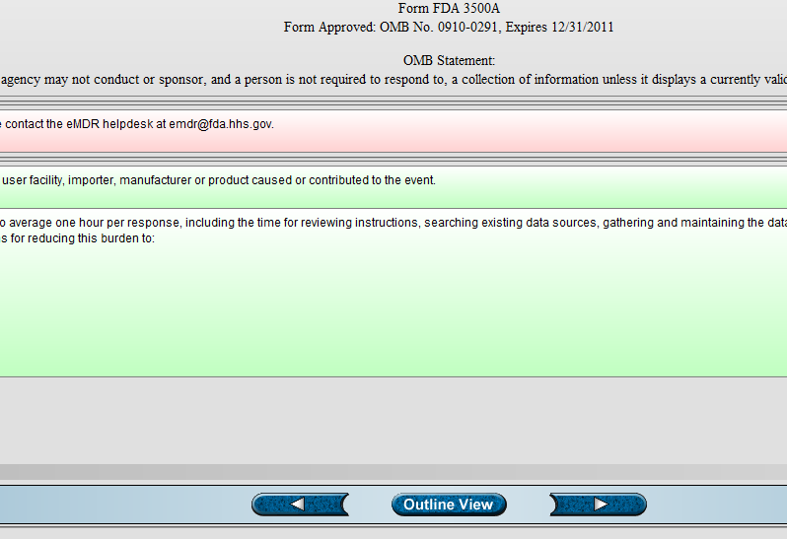

Clicking on the “Outline View” will allow you to choose the section of the 3500A form you wish to enter. Note that Section C is not applicable for eMDRs and section F is not applicable for medical device manufacturers.

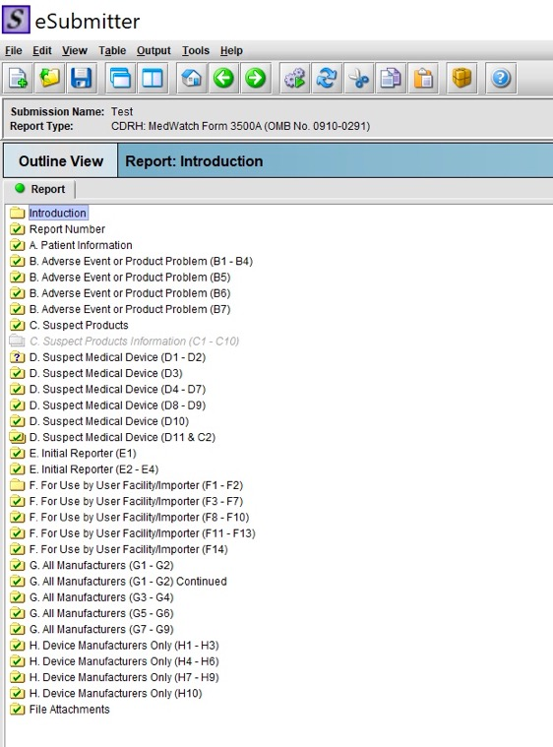

In the “Report Number” Field, select the “MFR Report Number” (MDR#) from the drop-down list and enable the button for “CFN based” (7 digits) or “FEI based” (10 digits; FDA Establishment Identifier) number. Enter the Manufacturer Report Number.

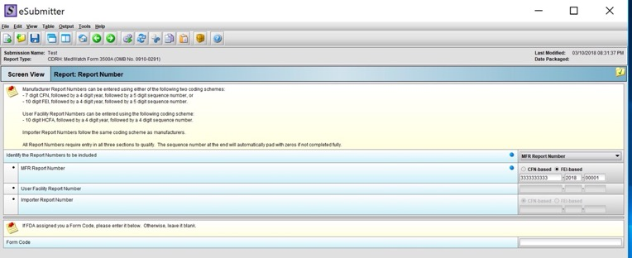

Manufacturer Report Number consists of the following three parts:

The FDA registration number for the manufacturing site of the reported device;

The four-digit calendar year in which the report is submitted; and

The five-digit sequence number of the reports submitted during the year, starting with 00001. (For example, the complete number will appear as follows: 0000000000-2018-00001.)

Begin entering all the fields on the 3500A form. Section A is shown below for an example. Click on the “Save” button to save as you enter information. Continue entering the MDR information into Parts: A, B, D, E, G. and H. 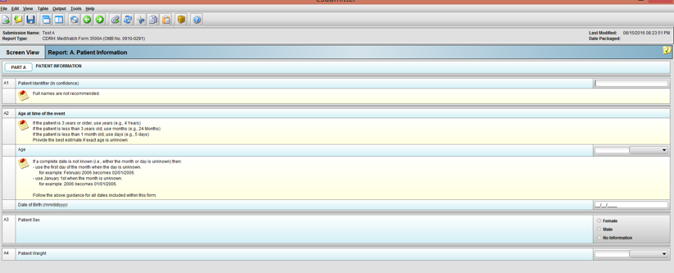

When you are finished entering all the MDR sections, save the file and verify that the information has been entered correctly and the form is complete. If you would like to proofread a paper version of the entire MDR report, you can create a PDF file by performing the following steps:

Select “Submission Report” from the Output taskbar.

Select “System Default Viewer” and click “OK”. Note: when setting up your computer, ensure Adobe is your default viewer. 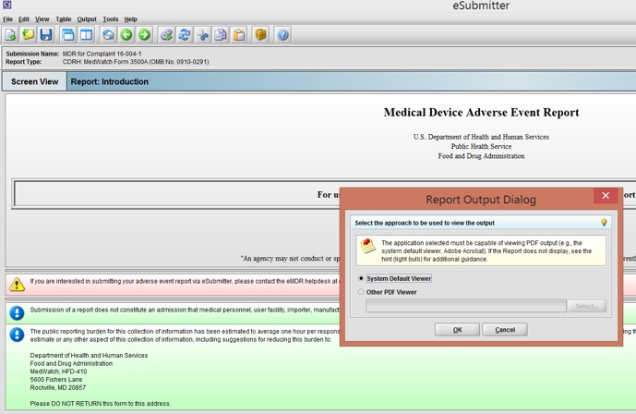

This will generate a PDF file of the eMDR report in the format of the FDA 3500A form. You can print and/or save this file and proofread and finalize as needed.

If you want to save the file and go back to work on it later or make final edits to the report, go to the top task bar and select “File” then “Open” and select the desired file from the list.

Once you have verified that the MDR is complete, save the file. When you are ready to submit to FDA, you first need to run a Missing Data Report. To run this report, go to the top task bar and select “Output” then “Missing Data Report”. The following dialog box will appear. Click “OK” and the system will open the report in your computer’s default browser. 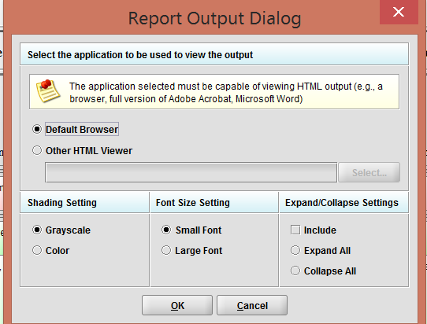

If there is any missing data, the report will identify which fields need to be entered before proceeding to the next step. Continue entering all required data and saving the file, repeating step 6.12 until you receive the following notice stating that, “There are no missing data from required fields. The report is adequate for submission.” 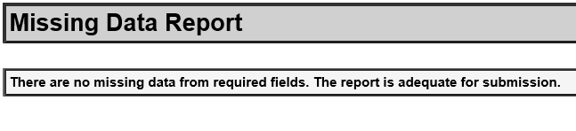

Now you are ready to package your submission to get it formatted so that it can be transmitted electronically to FDA/CDRH. To do this, go to the main menu task bar and select “Output” then select “Package Submission Files”. The name that you entered in section 6.4 should appear below and the file will be saved to the designated output location. Make note of where the output location is on your computer because you will need to access this location later. When you are ready, click the “Next” button. Note: When setting up eSubmitter for the first time, the setup instructions should default to saving eMDR files to C:\Users\Public\Sub_Home\Output (or a similar location). 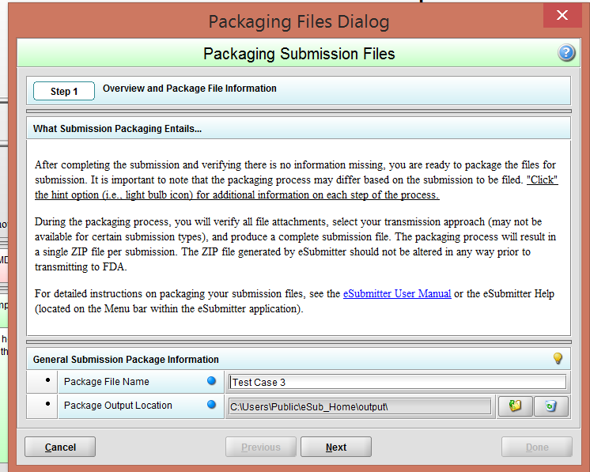

When you get to “Step 2”, click the “Next” button. 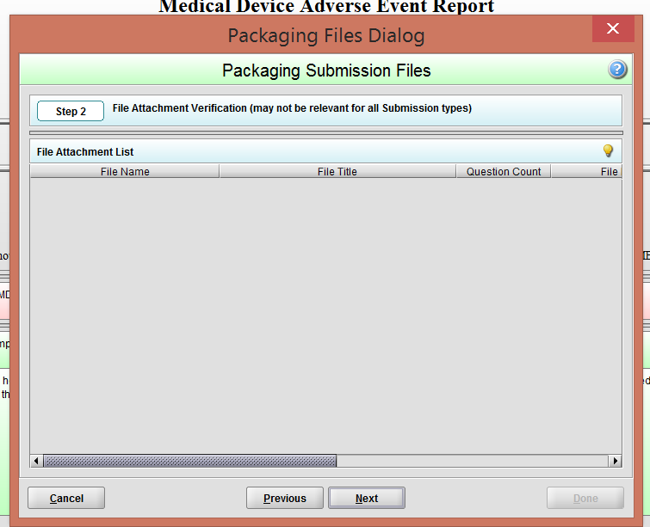

When you get to “Step 3”, click on the “Package Submission Files” button. Wait until progress bar shows as 100% complete. 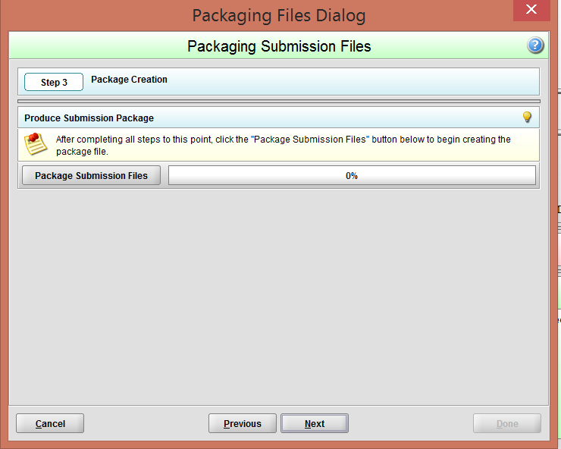

Now your eMDR is ready to be transmitted to FDA/CDRH.

Follow the steps below (see section 6.15) to transmit an eMDR report to FDA/CDRH using the FDA’s ESG Web Trader Hosted Solution (WTHS).

The steps for preparing a supplemental or follow-up report are the same as those for initial or 30-day reports. For all updates you should include the intital report number (see section 6.8 above) and select the type of submission as a “follow-up” report. Make sure that the manufacturer report number for the previously submitted initial or 30-day report is recorded in section G9. In the blank provided in block G7 after “Follow-up Number”, record the appropriate sequence of follow-up to that particular initial report (e.g., first follow-up report = follow-up #1, second follow-up report = follow-up #2, and so on).

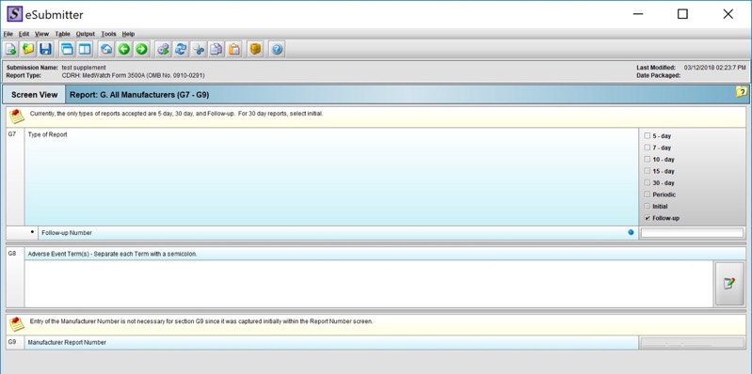

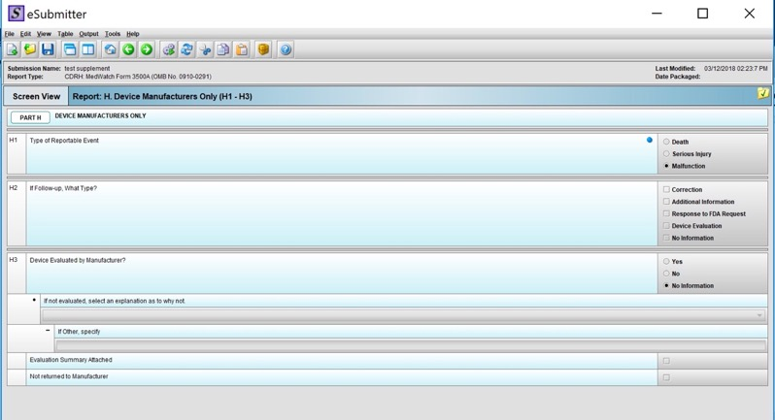

Limit your additional entries to those where you need to update previously provided information. For example, if patient age and sex are unchanged, do not include them in your supplement or follow-up report. If you are updating or correcting the model number, provide the corrected information only.

To transmit eMDR report, log onto the ESG WTHS using your user name and password.

Double click to access your “ESG Production” account.

You will be directed to the FDA Submissions home page.

Click on the home button and the system will load your previously submitted eMDR transmissions and the status of each.

In order to transmit a new eMDR report to FDA/CDRH, click on the WebTrader button and select “Send Document”.

From the Center drop-down list, select “CDRH”. From the Submission Type drop-down list, select “Adverse Events”. For the Path, click on the browse button and enter the location where the eMDR file is located on your system (refer to section 6.13). Your digital certificate will default to the designated file location that you previously set up during the eMDR validation process.

Click the Send button and you will be prompted to enter your password for your digital certificate. Enter your password and continue until the file has been successfully transmitted to the FDA. Go to your My Submissions home page to check the status until the Initial Receipt and all 3 Acknowledgements have been sent by the FDA. Once you receive the successful 3rd Acknowledgement, the eMDR has been submitted to the FDA and no further action is needed.

Verify successful submission of the eMDR

FDA’s system will automatically route 3 separate acknowledgements to the user’s ESG account. These acknowledgements indicate the stage of processing that the eMDR has reached.

Acknowledgement 1, also known as the Receipt or MDN (Message Disposition Notification) acknowledgement, indicates that the ESG received the eMDR.

Acknowledgement 2 indicates that CDRH has received the MDR.

Acknowledgement 3 indicates the pass or failure status of the eMDR into CHRH’s adverse event database – that is, whether the eMDR was successfully loaded into the database. This 3rd ACK serves as the final acknowledgement and a pass status tells you that the eMDR has been successful and no further action is needed.

If there are no errors, FDA anticipates that the 3 acknowledgements will be generated the same day or within 24 hours of the submission. FDA considers the receipt date for the eMDR to be the date the eMDR arrived at ESG (acknowledgement 1), but ONLY if the eMDR is successfully loaded in the CDRH database (a passing ACK 3). If a failure occurs during the validation or loading process, the error is described in ACK 3. If the resubmitted eMDR is then successfully loaded (a passing ACK 3), the receipt date will be the new date that the resubmitted eMDR arrived at the ESG (as documented in ACK 1). Note that the FDA time stamp is for EST/EDT, however local time zones are recognized.

If there are errors at any stage, refer to the Troubleshooting instructions below.

Troubleshooting Transmission Problems

If the eMDR transmission is not successful (failed status or no final acknowledgement received from FDA), perform the following steps:

Run a missing data report to verify that there’s no missing data.

If missing data and the eMDR was sent to FDA with missing data, re-package the eMDR and re-submit to FDA.

If there was no missing data and you believe the eMDR was correctly formatted, contact the FDA ESG Help Desk at ESGHelpDesk@FDA.hhs.gov. Provide the ESG Help Desk with the CORE ID # along with an explanation of the problem.

Once the problem has been identified, the report can be corrected, saved, repackaged, and resent to FDA.

Refer to FDA Guidance “Questions and Answers about eMDR” for additional troubleshooting instructions, including what to do when there are system outages.

Create a PDF file of the eMDR report. QA/RA will import into appropriate complaint file and MDR file within FileHold.

